Workshop on “Identification and Culture of Zooplanktons” Held at JSS College of Arts, Commerce and Science, Ooty road, Mysuru on 15-10-2025
The Postgraduate Department of Zoology, JSS College of Arts, Commerce and Science, Ooty road, Mysuru, organized a one-day workshop on “Identification and Culture of Zooplanktons” on 15-10-2025, aimed at imparting both theoretical and practical knowledge on the study, collection, identification, and culture of zooplanktons — the microscopic yet vital components of aquatic ecosystems. A total of 60 participants attended the workshop.
The inaugural session was presided over by Prof. B. V. Sambashivaiah, Chief Executive of the college. In his presidential remarks, he emphasized the importance of skill-based learning and research-oriented education in higher studies, and appreciated the department’s initiative in organizing a program that blends field-based exploration with laboratory application.
Dr. M. Prabhu, Principal of the college, delivered the Concept Note, highlighting how such hands-on workshops align with the objectives of the National Education Policy (NEP 2020), which encourages experiential learning and innovation in higher education.
The Resource Person, Dr. T. S. Harsha, Associate Professor and Chairman, Department of Environmental Science, Karnataka State Open University, Mysuru, inaugurated the workshop and delivered the inaugural address. In his talk, he elaborated on the ecological and economic significance of zooplanktons, emphasizing their role as bioindicators of water quality and their growing importance in aquaculture and sustainable ecosystem management.
The program began with an invocation by Ms. Chinmayi of first semester M.Sc., Zoology, followed by the welcome address by Dr. Ramyashree M., Head, PG Department of Zoology. Ms. Misba Anjum of third semester M.Sc., Zoology efficiently conducted the program as Master of Ceremony, Ms. Ashwini introduced the resource person Dr. T.S. Harsha Associate Professor and Chairman, Department of Environmental Science, Karnataka State Open University, Mysuru by delivering his academic and research acheivements. Ms. Sheethal of first semester M.Sc., Zoology proposed the Vote of Thanks, expressing gratitude to all dignitaries, participants, and supporting staff.
Following the inaugural session, the workshop continued with a series of technical and practical sessions designed to give participants hands-on exposure. In the first technical session, Dr. Harsha gave a elaborate lecture on Biology of zooplankton, their classification, and ecological roles in aquatic ecosystems.
The second technical session included a field visit to the Suttur Math Pond, where participants observed the pond ecosystem and learned field techniques for the collection of water samples used in zooplankton studies. The resource person demonstrated methods of sampling, filtration, and handling of specimens, helping students gain first-hand experience in ecological data collection.
In the afternoon practical session, students analyzed the physicochemical parameters of the collected water samples and learned the procedures for identification of various zooplankton groups under the microscope. The session also included demonstrations on culturing techniques for zooplanktons, their preservation, and fixation methods for future laboratory use and research studies.
The workshop concluded with a valedictory session, where participants shared their learning experiences and expressed appreciation for the valuable insights gained. The event successfully combined academic learning with field practice, fostering curiosity and practical skills among the students.
The workshop was coordinated by Dr. Ramyashree M., Head of the Department of Zoology, with the active support of all faculty members such as Dr. Nijagal B.S, Dr. Navyashree, Ms. Sowmya G., Ms. Anjali G.M and student volunteers. Around 60 participants, including postgraduate students and faculty members, took part in the program.
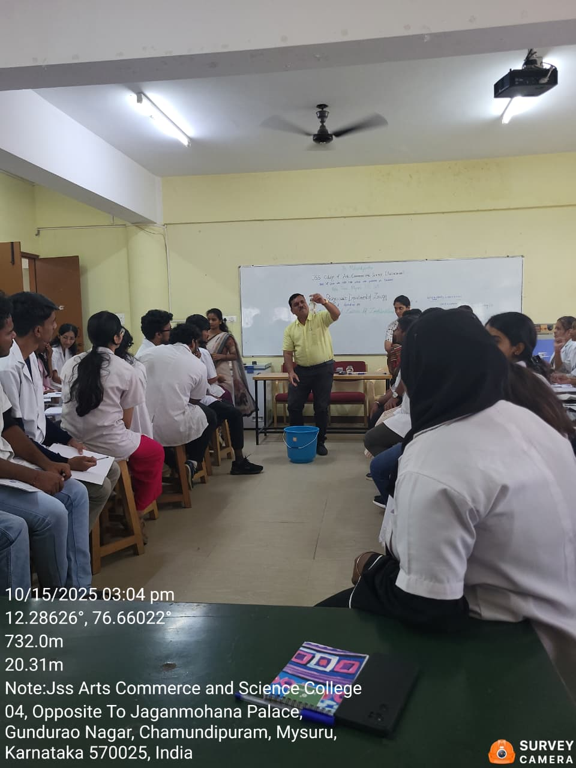
The workshop was well-received by all participants and served as a significant step in promoting experiential learning, environmental awareness, and skill development in biological sciences.
