# JSS COLLEGE OF ARTS, COMMERCE & SCIENCE

**(An Autonomous College of University of Mysore)**

## OOTY ROAD, MYSORE-570 025 KARNATAKA

Re-accredited by NAAC with ‘A’ grade Recognised by UGC as “College with Potential for Excellence”

Ph: 0821-2548236 & 2548380. FAX: 0821-2548238 E-mail: [jssautonomous@gmail.com](mailto:jssautonomous@gmail.com) Website: JSSCACS.edu.in

**DEPARTMENT OF ECONOMICS**

# INDIVIDUAL PROFILE

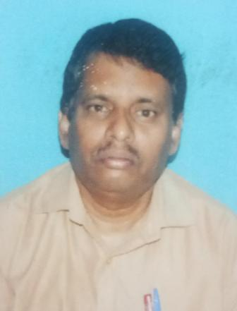

## C RAMESH

|  |  |  |  |
| --- | --- | --- | --- |
| 1. | Name | - | C RAMESH |
| 3. | Qualification | - | MA |
| 4. | Designation | - | Associate professor |
| 5. | Date of entry into service | - | 01-07-1986 |
| 6. | Experience | - | 33 Years |
| 7. | Contact No./ Email | - | 9980790215. Rameshchikk@gmail.com |
| 8. | Positions held | - | Member of BOS & BOE, Academic council. |

**Date of transfer- 02/07/2018**