***Faculty Template***

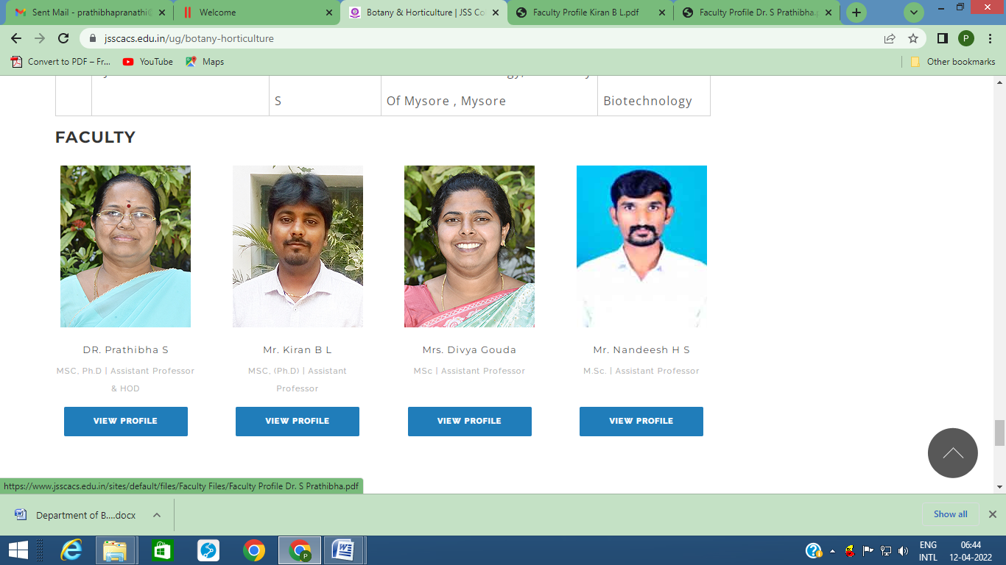

***Name :*** Dr.Smt. PRATHIBHA, S.

***Designation :* Associate Professor and H.O.D of Botany**

***Email – Id :*** [**prathibhapranathi@gmail.com**](mailto:prathibhapranathi@gmail.com)

***Qualification :* M. Sc., Ph. D.**

***No. of Publications :* 06**

***Know More***

**Educational Qualification :**

|  |  |  |  |
| --- | --- | --- | --- |
| **Sl.No** | **Qualification/Programme** | **Institution / University** | **Year of Passed Out /Period** |
| 1. | M.Sc | University of Mysore | 1986 |
| 2. | Ph. D. | Kuvempu University | 2006 |

**Work Experience:**

|  |  |  |  |
| --- | --- | --- | --- |
| Sl.No | Institution Name / Employer Name | Designation / Department | Period |
|  | JSS College, Ramanuja Road, Mysore-570 004 | Stop-gap Lecturer in Botany | 1986-1992 |
|  | JSS College, Ooty Road, Mysore-570 025 | Lecturer in Botany / Microbiology | 1992-1998 |
|  | JSS College for Women, Chamarajanagar-577513 | Assistant Professor | Nov. 15, 1999 to July 3 2007 |
|  | JSS PU College for Women, Chamarajanagar-577513 | Principal | Mar 31 2005 to May 2 2006 |
|  | JSS College,Ooty Road, Devirammanahalli layout, Nanjangud-  (On Deputation from JSS College for Women, Chamarajanagar-577 513) | Associate Professor | July 3 2007 to Mar. 31 2009 |
|  | JSS College, Ooty Road, Mysore-570 025. (On Deputation from JSS College for Women, Chamarajanagar-577 513) | Associate Professor | Mar.31 2009 to July 15 2010 |
|  | JSS College for Women, Chamarajanagar-577513 | Associate Professor and H.O.D of Botany | July 15 2010 to 1st July 2014 |
|  | JSS College of Arts,Commerce and Science(An Autonomous College of University of Mysore)  B.N Road Mysore-570025 | Associate Professor and H.O.D of Botany | 1st July 2014 to till Date |

**Publications :**

* 1. Title : Diversity and Density of Coliform Bacteria in River Tunga at Shivamoga City, Karnataka India
  2. Name of the Journal : International Journal of current Microbiology and Applied Sciences
  3. Date of Publication : July 2015
  4. Volume No. / Issue No. / Page No. / Factor : Volume 4 Numbre 7(2015) pp-624-631/ 4.119
  5. Author : S. Prathibha and V.N.Murulidhar

1. Title : Enumeration of Bacteria;A tool for water quality evaluation in Tunga reservoir at gajanur, karnataka
2. Name of the Journal : International Journal of advanced research (IJAR)
3. Date of Publication : Dec 2018
4. Volume No. / Issue No. / Page No. / Factor : ISSN :2320-5407 Volume 6 (12)/ 7.08
5. Author : S. Prathibha and V.N.Murulidhar

3.

1. Title : Fragile X Syndrome: Epigenetics marks in the Therapy
2. Name of the Journal : European Journal of Molecular & Clinical Medicine
3. Date of Publication : Jan 2021
4. Volume No. / Issue No. / Page No. / Factor : ISSN 2515-8260 Volume 07, Issue 07, 2020
5. Author : Shreya shreshtha, Raghu N, Gopenath TS, Parthiban R, Prathibha Rajashekara S , Kanthesh M Basalingappa

4.

1. Title : Ferroptosis and its facet in Cancer therapy
2. Name of the Journal : MOJ Biology and Medicine
3. Date of Publication : Jan 2021
4. Volume No. / Issue No. / Page No. / Factor : Volume 6 Issue 1 - 2021
5. Author : Shreya shreshtha, Gopenath TS, Parthiban R, Prathibha Rajashekara S , Kanthesh M Basalingappa

5.

1. Title : Evaluation of Probiotic Strains of Lactobacillus species from Traditional animal sources and alternative plant sources
2. Date of Publication : March 2021
3. Publisher : Greens Publications Green trust, India
4. Author : Dinesh Kumaar, V., Dr. Kanthesh, M., Basalingappa, Dr. S. Prathibha

6.

1. Title : Coronavirus Diseases (COVID-19): Features, Epidemiology, Mutational Variations and Treatments Across India
2. Name of the Journal : Journal of Pure and Applied Microbiology (JPAM)
3. Date of Publication : Dec 2021
4. Volume No. / Issue No. / Page No. / Factor : 15(4):1798-1808
5. Author : Sayani Jati, Kanthesh M. Basalingappa, B. Geethanjali, R. Parthiban, S. Prathibha Rajashekara and T.S. Gopenath

**M.Phil / Ph.D Thesis:**

|  |  |  |  |  |
| --- | --- | --- | --- | --- |
| **Sl.No** | **Title** | **Guide Name** | **Institution** | **Month / Year** |
|  | Environmental Science | Dr. E. T. Puttaiah  Dept. of Environmental Science  Co-guide: Keshava Niresh Wariya  Senior scientist  Lab 4, Food Microbiology, CFTRI, Mysuru | Kuvempu University, Jnanasahyadri, Shankaraghatta-577451  Karnataka | Feb 15  2006 |
|  |  |  |  |  |