Faculty Profile

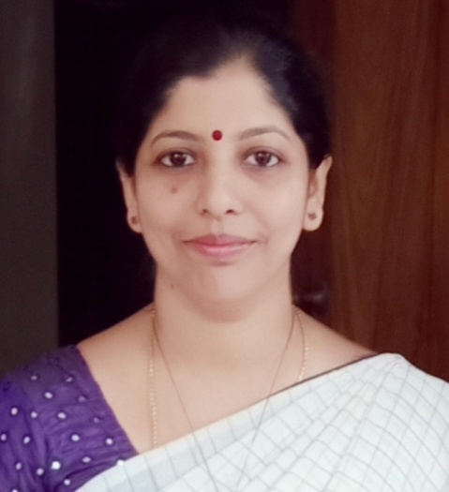

**Mrs. Meera C** M.Sc., PG Dip Animation. ASSISTANT PROFESSOR

**Qualification**

|  |  |  |
| --- | --- | --- |
| **Programme** | **Specialization** | **Institution/University** |
| M.Sc | Computer science | University of Mysore |
| PG Diploma | Animation | JSS College of Arts, Commerce & Science,  Mysore |
| **Total Experience: 13years above** | | |

|  |  |  |  |  |
| --- | --- | --- | --- | --- |
| **Seminars/Conferences/Symposium/Workshops** | | | | |
| **Sl.No** | **Name of the**  **Conference**  **/Seminar**  **/Symposium/Workshop** | **Type of**  **Program** | **Role** | **Venue/ Place** |
| 1. | **PROMOTION OF RESEARCH IN COLLEGES** | **Workshop** | **Participant** | **JSS College of Arts, Commerce & Science,**  **Mysuru** |
| 2. | **TEACHING AN D LEARNING IN THE 21ST CENTURY- STUDENT CENTRIC**  **APPROACH** | **Orientation**  **Programme** | **Participant** | **JSS College of Arts, Commerce & Science, Mysuru** |
| 3. | **CORE COMPETENCY IN COMPUTING** | **Seminar** | **Participant** | **JSS College of Arts, Commerce & Science,**  **Mysuru** |
| 4. | **CHOICE BASED CREDIT SYSTEM(CBCS)** | **Seminar** | **Participant** | **JSS College of Arts,**  **Commerce & Science, Mysuru** |
| 5. | **LaTex workshop** | **Seminar** | **Participant** | **JSS College of Arts, Commerce & Science,**  **Mysuru** |
| 6. | **Faculty Induction Programme** | **Workshop** | **Participant** | **JSS College of Arts,**  **Commerce & Science, Mysuru** |
| 7. | **Teacher’s Capacity Building** | **Workshop** | **Participant** | **JSS College of Arts, Commerce & Science,**  **Mysuru** |
| 8. | **UGC Sponsored Four Days Frontier Series** | **Seminar** | **Participant** | **JSS College of Arts,**  **Commerce & Science, Mysuru** |
| 9. | **Emerging Trends in Internet of Things** | **Workshop** | **Participant** | **JSS College of Arts, Commerce & Science,**  **Mysuru** |
| 10. | **Data Science** | **Seminar** | **Participant** | **MMK-SDM Mahila Mahavidyalaya,Mysuru** |
| 11. | **UGC Sponsored One Day State Level “Orientation and Retraining Programme for Teachers”** | **Workshop** | **Participant** | **JSS College of Arts, Commerce & Science,**  **Mysuru** |
| 12. | **“One Day State Level Orientation and Retraining Programme for Teachers”** | **Workshop** | **Participant** | **JSS College of Arts, Commerce & Science,**  **Mysuru** |

1. Member of BOE – JSS College for Women’s, Saraswathipuram, Mysuru, 2017-2018.

2. Member of BOE – ST Philomena’s College, Mysuru, 2016-2017.

3. Member of BOE –Yuvaraja’s College, Mysuru, 2021-2022.

4. Member of BOS – JSSCACS, Mysuru.

LIFE MEMBER:

Indian Science Congress.