FACULTY PROFILE

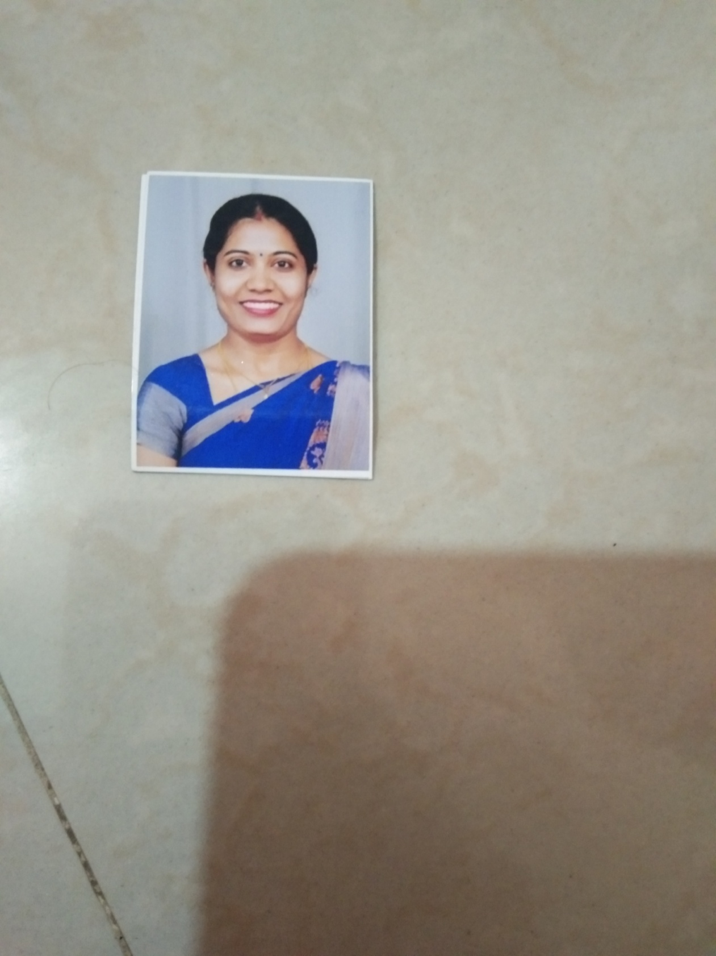

**Smt.Shwetha R**

**M.Sc, B.ed**

**ASSISTANT PROFESSOR**

# Qualification:

|  |  |  |  |
| --- | --- | --- | --- |
| **Degree** | **University/Institution** | **Year** | **Specialization** |
| MSc | JSS College of Art’s Commerce and Science | 2018 | General Chemistry |
| B.Ed | Moulanaazzad B. Ed college | 2012 | Chemistry & Biology |

**Seminars/Conferences/Workshop/ symposia attended.**

|  |  |  |  |
| --- | --- | --- | --- |
| **Name of the**  **Teacher** | **Title of the Event** | **Organizer** | **Date and Year** |
| **Smt. Shwetha R** | Orientation and retraining programme for teachers | JSSCACS,Mysore | 14 january 2022 |
|  | UGC sponsored one day state level orientation and retraining programme for teachers | JSSCACS | 14 january 2022 |
|  | day state level orientation and retraining programme for teachers | JSSCACS | 28 february 2022 |